**The Evolution of Banking in Technology**

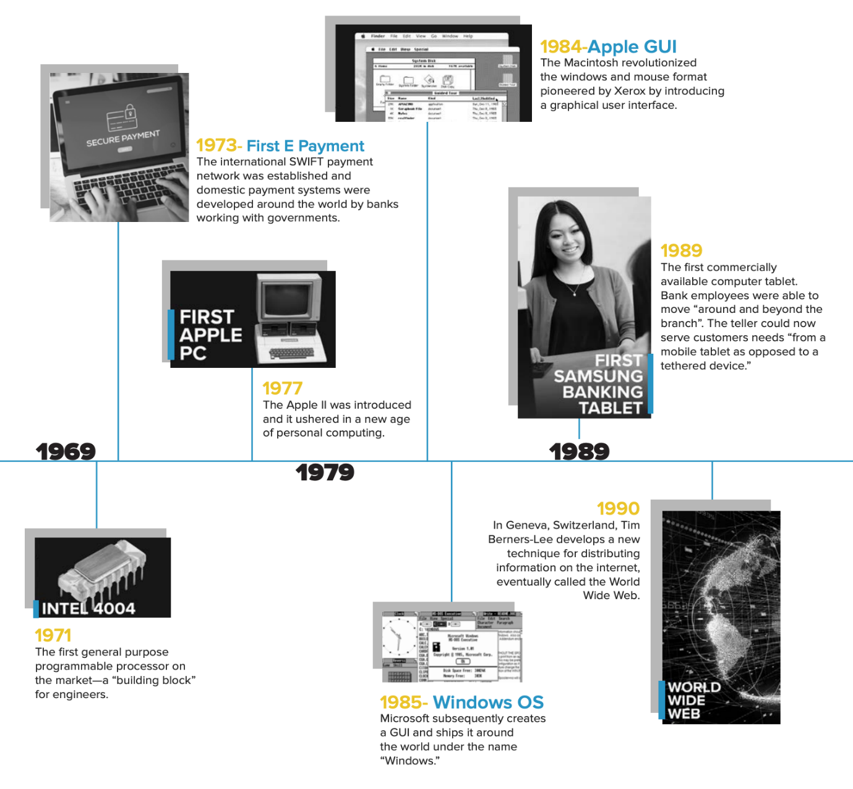

**The Introduction of the Credit Card**

The first and most notable technological advancement in the financial industry was the advent of the credit card in 1950. Diners Club introduced the first universal credit card, a portable payment solution that could be used at numerous member establishments.

The introduction of the credit card fundamentally changed how consumers thought about their finances. They no longer had to carry or spend cash for every purchase. They now had the freedom to borrow against a line of credit that they could pay off at a future date. In general, credit cards allow consumers to make bigger purchases, without having to dip too deep into their savings.

**ATMs, Computers in Banking, and Much More**

Fast forward a little over a decade later to the 1960s, when the world was introduced to the first ATM. A Scottish inventor named John Shepherd-Barron [thought] if vending machines could dispense chocolate bars, why couldn’t they dispense cash? Barclays Bank fell in love with the idea and the first ATM was created. With the invention of the ATM, customers were no longer constrained by bank hours and locations when they wanted to access their money.

The use of computers in banking was also introduced in the 1960s when the then-Bank of New South Wales announced it would purchase its first-ever computer for the sum of £1 million. That’s about $26 million in today’s USD.

The use of computers sparked the first [digital banking revolution](https://www.mx.com/whitepapers/consumer-trends-digital-and-mobile-banking/).

The computer centralized the bank’s trading accounts by replacing the machine accounting operations used in each individual branch. The hope was that a centralized place for accounts would streamline processes and allow financial institutions to place a stronger focus on customer service.

The use of computers sparked the first digital revolution. Banks started to invest heavily in computer technology to automate manual processing. By the 1970s, the first electronic payment systems for both international and domestic transactions were developed. The international SWIFT payment network was established in 1973, and domestic payment systems were developed around the world by banks working with governments.

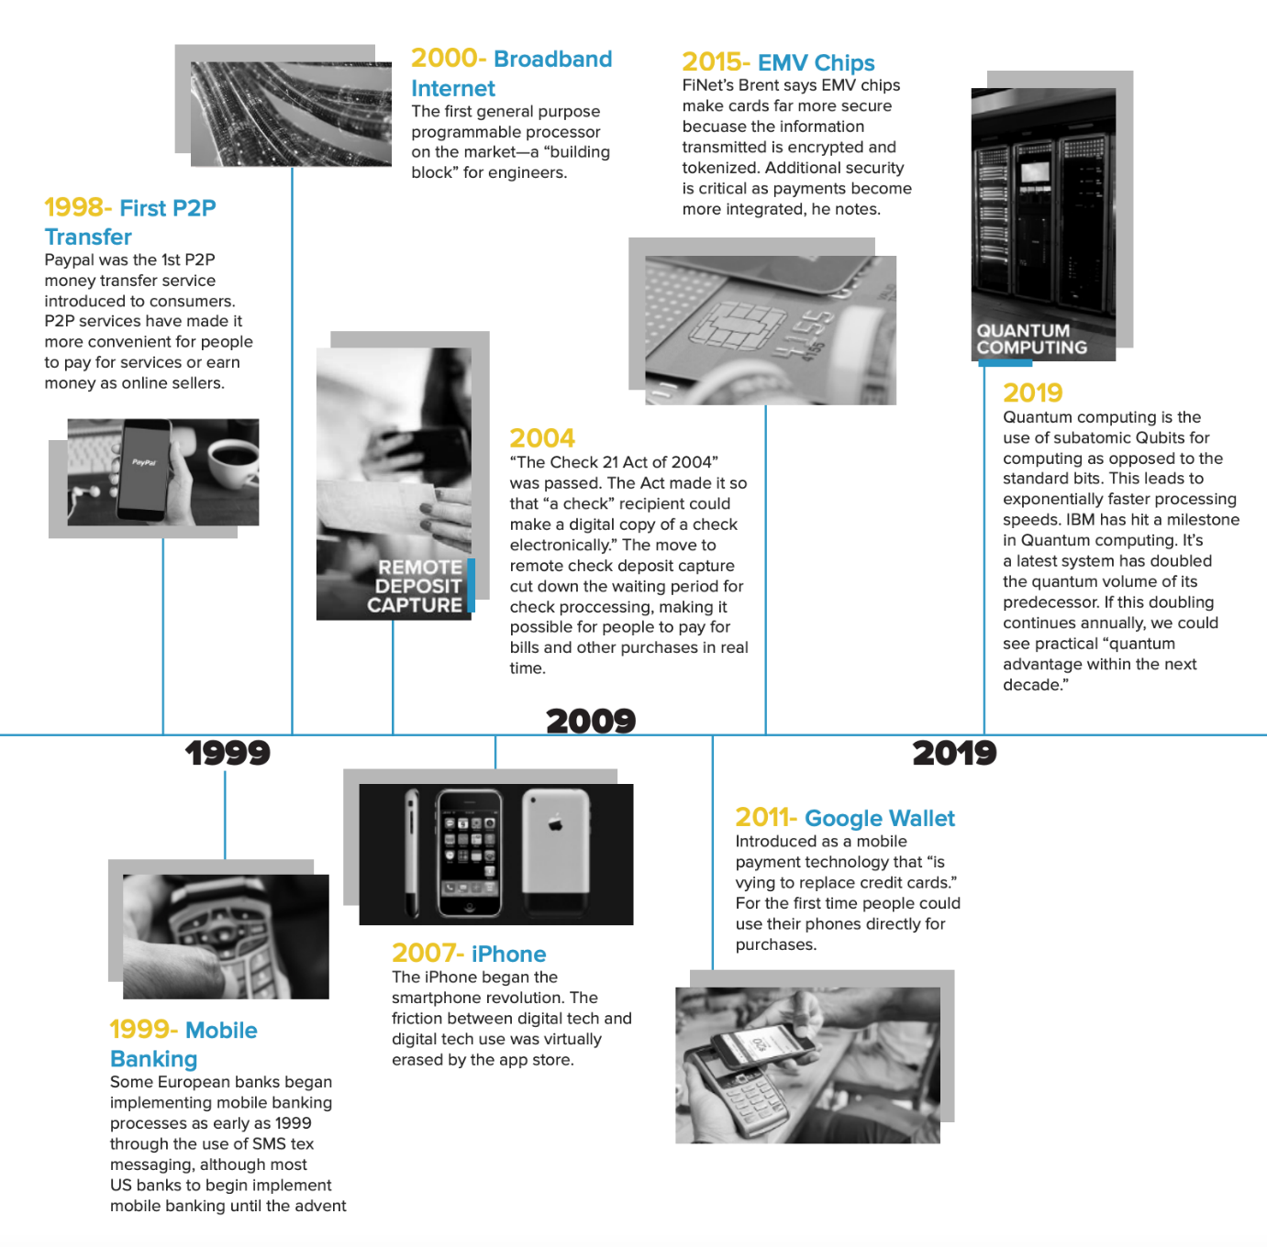

## The Convenience of Online Banking

In the 1980s, with digital technology well underway, the term ‘online’ — which referred to the use of a terminal, keyboard and TV to access the banking system using a phone line — gained popularity. With online banking came the benefits of lower transaction costs, easier integration of services, and more targeted marketing capabilities.

As online banking gained momentum, the first commercially available computer tablet, manufactured by Samsung in 1989, brought a new wave of convenience in retail banking. For the first time bank employees were allowed to “move within and even beyond the branch. Instead of waiting in line for the teller to become available, the teller might come to the door, greet a customer, sit on the couch with them and serve their needs from a mobile tablet as opposed to a tethered device.

Late in the 1990s, consumers were introduced to PayPal, a P2P money service, enabling wireless transfers. The creation of PayPal spawned a myriad of like businesses from Venmo and Popmoney to Zelle. These services made it more convenient for people to pay for services wirelessly.

## The Mobile Banking Revolution

The early 2000s, with the advent of wireless technology and the wide adoption of smartphones, brought the next major shift in the financial industry—mobile banking. Mobile banking made it possible for people to manage their financial lives from virtually anywhere and at any time. Now people could pay bills, check balances, transfer funds, or add new accounts all from their mobile devices. For the first time, the branch experience started to become secondary, as people flocked to the convenience and easy of their mobile devices.

In 2004, as mobile banking continued to grow in popularity, “the Check Clearing for the 21st Century Act” 3 was passed. The Act made it so “a check recipient could make a digital copy of a check and then process that check electronically.” The move to remote check deposit capture reduced the waiting period for check processing, adding convenience and making it possible for people to pay for bills and purchases faster than ever before.

About seven years later in 2011, Google introduced Google Wallet, a mobile payment technology meant to rival credit cards. For the first time people could use their phones directly for purchases. This opened up a whole new level of freedom, taking technology in the financial industry to a whole new level. Similar to Google Wallet, in 2014, Apple launched Apple Pay.

Heading the charge in 2015, “Bank of America... introduced fingerprint authentication and Touch ID,” making it easier and safer for people to log into their mobile banking apps. In the same year, the EMV chip technology became a standard among card issuers. The “EMV chips make cards far more secure because the information transmitted is encrypted and tokenized.” And it adds more security, which is “critical as payments become more integrated.”

## A New Era in Banking

Today we’re seeing another major shift in the financial industry, largely brought about by consumers’ expectations for convenience, relevance, and ease. As technology continues to advance in the banking industry, it’s fundamentally changing the banking model. Consumers expect hyper-personalized and relevant communication from all of their online and offline interactions. And they don’t want to initiate the conversation. They want their financial institutions to keep them in the know about their finances and notify them if something needs their attention. In essence, they’re looking for a self-guided financial wellness solution.

But what exactly does self-guided financial wellness mean? In short, it means proactive financial advice at the right moment and time—helping people stay on top of all of their financial matters in real-time. People no longer simply want to trust their financial institution with their money. They want to trust that their financial institution understands them and has their best interest in mind when it comes to financial matters.

Luckily, financial institutions are well positioned to take advantage of everything technology has to offer. It’s now easier than ever before for financial institutions to access and act on their wealth of data to help customers make well-informed financial decisions. Whether it’s mobile apps enabling budgeting, notifications encouraging better spending habits, or ads informing customers on where to go for a better mortgage loan—there’s a lot that financial institutions can do to help their customers.

And the best part is that financial institutions can do all this without having to fundamentally change their customers’ behavior towards finances. At MX, we’re ushering a new age of personal financial wellness with a tool that does all the heavy lifting—from proactive notifications to guided financial advice, so everyone has access to the financial information they need to lead happier and healthier financial lives.

Evaluating banking technology in the U.S. with the help of data involves looking at various metrics such as transaction speeds, adoption rates, security incidents, customer satisfaction scores, and investment in technology. Here’s an in-depth analysis supported by relevant data:

**1.Efficiency**

**Transaction Processing:**

Core Banking Systems: U.S. banks have significantly improved transaction processing times. For example, real-time payment systems like the RTP® network launched by The Clearing House process transactions within seconds.

Automation: According to a 2023 Deloitte report, over 70% of U.S. banks have implemented Robotic Process Automation (RPA) to streamline back-office operations, reducing processing times by up to 60%.

**Operational Efficiency:**

Cost Savings: McKinsey reported that digital banking channels could reduce the cost per transaction from $4 (branch) to $0.10 (online). Banks investing heavily in digital channels are seeing operational cost reductions.

Resource Management: CRM systems have improved lead conversion rates by 20%, as noted in a Salesforce study, showing better resource allocation and customer management.

**2. Security**

**Cybersecurity Measures:**

Data Encryption: Most major U.S. banks use advanced encryption standards (AES-256). The number of banks adopting end-to-end encryption rose by 30% from 2019 to 2023 (source: American Bankers Association).

Fraud Detection Systems: AI-driven fraud detection has reduced fraud losses by 50% for early adopters, as per a 2022 report by Javelin Strategy & Research.

Compliance: According to a 2023 PwC report, 90% of U.S. banks are compliant with GDPR and PCI DSS, indicating robust data protection practices.

**Authentication Methods:**

Biometric Authentication: A 2023 survey by FICO revealed that 60% of U.S. banks have adopted biometric authentication, such as fingerprint or facial recognition, enhancing security for mobile banking apps.

Multi-Factor Authentication (MFA): As of 2023, over 80% of U.S. banks offer MFA, up from 50% in 2018 (source: Cybersecurity Ventures).

**3. Customer Satisfaction**

**User Experience:**

UI/UX: According to J.D. Power’s 2023 U.S. Retail Banking Satisfaction Study, banks that invested heavily in UI/UX improvements saw customer satisfaction scores increase by 25%.

Accessibility: The same study noted that banks enhancing digital accessibility for people with disabilities experienced a 20% rise in overall customer satisfaction.

**Service Availability:**

Uptime and Reliability: Data from a 2023 Gartner report indicates that leading U.S. banks have achieved over 99.9% uptime for their online and mobile banking services.

Support Services: Banks using AI chatbots have reduced response times by 50% and improved customer issue resolution by 30% (source: Forrester, 2022).

**Innovative Services:**

Personalized Banking: A 2023 Accenture report found that 75% of U.S. banks use AI to offer personalized financial advice, leading to a 15% increase in customer retention.

Integration with Fintech: Partnerships with fintech firms have grown by 40% since 2019, with services like peer-to-peer payments and robo-advisors gaining popularity (source: CB Insights).

**4. Innovation**

**Emerging Technologies:**

Blockchain: A 2023 Deloitte survey showed that 40% of U.S. banks are exploring blockchain for secure and transparent transactions, with JPMorgan Chase’s JPM Coin being a notable example.

Artificial Intelligence (AI): AI adoption in U.S. banks has risen by 50% over the past three years, with applications in customer service and fraud detection leading to operational efficiency gains (source: McKinsey).

Internet of Things (IoT): IoT use cases, such as smart ATMs and connected branch devices, are being piloted by major banks, enhancing customer engagement and operational monitoring (source: IDC, 2023).

**Research and Development:**

Investment in R&D: According to a 2023 study by the Federal Reserve, U.S. banks collectively invest over $20 billion annually in R&D for new technologies.

Partnerships and Collaborations: Banks are increasingly partnering with tech firms, as evidenced by a 30% increase in fintech collaborations from 2019 to 2023 (source: BCG).

Case Studies and Examples

Digital-Only Banks: Chime, a leading digital-only bank, has seen its customer base grow to over 12 million by 2023, highlighting the success of mobile-first banking solutions.

Blockchain in Banking: JPMorgan Chase’s use of blockchain for its Interbank Information Network (IIN) has improved cross-border payment processing speeds and transparency.

AI in Banking: Bank of America’s Erica chatbot, leveraging AI, handled over 100 million customer interactions in 2023, demonstrating the effectiveness of AI in enhancing customer service.

**Conclusion**

The evaluation of banking technology in the U.S. shows significant advancements in efficiency, security, customer satisfaction, and innovation. The use of data underscores the tangible benefits these technologies bring, from reducing operational costs and enhancing security to improving customer experiences and fostering innovation.

**Banking system resilience during economic crises**

In less than two decades, the world has experienced two historically deep negative shocks to the global economy and financial system. While their causes were different, the global financial crisis of 2008 and the COVID-19 pandemic that hit in 2020 each necessitated the intervention of central banks in ways not contemplated in earlier decades. Last spring, the Fed was required to intervene again to address stresses in the banking system precipitated by the failures of Silicon Valley Bank (SVB) and Signature Bank.

The global financial crisis followed a period of low interest rates in the first half of the 2000s. The stresses of last March occurred in an environment of high and rising interest rates. This is a reminder that regardless of the interest-rate environment, financial system vulnerabilities can help propagate adverse shocks across the financial system and sometimes very quickly. Indeed, both bankers and supervisors were caught off guard by the speed with which deposits flowed out of Silicon Valley Bank. Over $40 billion of deposits left the bank on March 9, 2023, and another $100 billion was expected to leave the next day, making the two-day total about 85 percent of the bank’s deposits. In comparison, when Wachovia failed in 2008, the deposit outflow was lower and slower: about $10 billion flowed out over eight days.

The resilience of the U.S. banking system during economic crises, including the 2008 financial crisis and the COVID-19 pandemic, showcases its ability to adapt and recover through robust regulatory frameworks and crisis management strategies.

**2008 Financial Crisis**

**Immediate Impact:**

The crisis caused major financial instability, leading to a 4.3% GDP contraction in 2009 (Bureau of Economic Analysis).

Bank failures were rampant, with Lehman Brothers' collapse symbolizing systemic weaknesses.

**Response and Recovery:**

The $700 billion TARP stabilized banks through capital injections.

The Federal Reserve cut interest rates to near 0% and introduced quantitative easing (QE).

Regulatory reforms via the Dodd-Frank Act implemented stricter oversight and stress tests.

By 2010, Tier 1 capital ratios for large banks improved to 12-14%, enhancing stability (Federal Reserve).

**COVID-19 Pandemic**

During COVID-19, the U.S. banking sector remained stable despite economic challenges. GDP fell by 3.5% in 2020 (Bureau of Economic Analysis). However, banks maintained strong capital positions due to post-2008 reforms. The Federal Reserve's emergency measures, including cutting interest rates to 0-0.25% and providing liquidity through programs like the Main Street Lending Program, helped stabilize the system. Stress tests in 2020 showed banks could endure severe scenarios (Federal Reserve). The CARES Act's $2 trillion relief, including the Paycheck Protection Program, supported businesses, aiding banks by reducing defaults and ensuring liquidity.

**Immediate Impact:**

The pandemic led to a sharp economic downturn, with a 3.5% GDP contraction in 2020 (Bureau of Economic Analysis).

Economic uncertainty increased, but banks remained relatively stable due to post-2008 reforms.

**Response and Recovery:**

The CARES Act provided $2 trillion in economic relief, including the Paycheck Protection Program (PPP) to support businesses.

The Federal Reserve cut interest rates to 0-0.25% and resumed QE.

Emergency lending programs, like the Main Street Lending Program, ensured liquidity.

Despite the crisis, banks maintained strong capital positions, with stress tests in 2020 showing banks could handle severe economic conditions (Federal Reserve).

**World War 2**

During World War II, the U.S. banking system remained stable and supported the war economy. The Federal Reserve kept interest rates low to finance the war effort, and War Bonds channeled public savings into government coffers. From 1941 to 1945, U.S. government debt rose from $48.6 billion to $258.7 billion (Treasury Department). Banks played a crucial role in managing this debt and financing war production. Post-war policies, including the GI Bill, helped transition the economy to peacetime, stabilizing banks and promoting growth. This period highlighted the banking sector's adaptability and critical role in national economic efforts.

**Conclusion:**

The U.S. banking system’s resilience during the 2008 financial crisis and the COVID-19 pandemic highlights its improved regulatory environment, robust capital buffers, and effective crisis response measures. These factors ensure that banks can withstand economic shocks, maintain stability, and support economic recovery.

**How the whole economy impact on import and export**

Economic crises impact U.S. banking and trade significantly. During the 2008 crisis, GDP dropped by 4.3% in 2009, causing imports to fall from $2.1 trillion to $1.6 trillion and exports to drop from $1.8 trillion to $1.5 trillion (U.S. Census Bureau). In the COVID-19 pandemic, GDP contracted by 3.5% in 2020, similarly reducing trade volumes. Lower domestic demand decreased imports, while global recession reduced exports. These declines affect bank revenues from trade financing and foreign exchange services, highlighting the interconnectedness of economic health and banking stability.